Kinematic Structure of the NUWAR Robot

Mechanical Structure
The kinematic structure of the NUWAR robot is very similar to that for the DELTA robot (on which it is based). Shown below is a simplified view of the NUWAR robot showing the basic structural components:

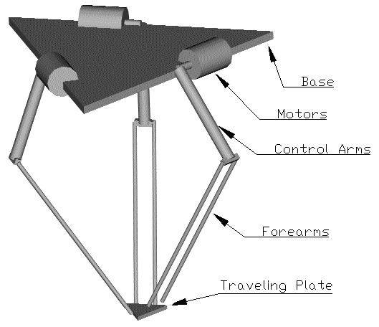

Fig. 9: Mechanical Structure of the NUWAR Robot (α, β = 0 degrees) [Parker98]

The upper part of the robot consists of a base plate and three actuators. These three actuators are placed in a circle, 120 degrees apart. The centre of the base plate corresponds to the centre of this circle. They activate the translations of the gripper plate in Cartesian space. Thus, this robotic mechanism transforms the rotational motion provided by the actuators (motors) to translational motion of the end-effector.
Each motor can be rotated in both the 'α' and 'β' directions. Each motor can be rotated in the 'α' direction about its own axis. The pivot points for the 'β' rotation have been set a distance 'Ra - Rb' away from the centre of the base plate as shown below. 'Rb' refers to the distance between the ends of each of the arms and the centre of the gripper plate.

Fig. 10: Pivot Locations for the Motors

Thus the distance between the motors and the centre of the base plate changes as 'β' is changed. The reason for this set-up will be explained shortly.
The positive convention for rotation in the 'α' direction is shown below.

Fig. 11: 'α' Rotation Convention

For different configurations corresponding to different values of 'α' and 'β', there exist equivalent configurations in which the robots workspace and kinematic performance are the same [Miller97]. These are summarised below:
Baseplane mirror image: α → -α, α → 180° - α, β → β + 180°;
YZ plane mirror: β → 180° - β;
180 degree rotation about Y axis β → -β;
Identical α → α + 180°.

Arm Extensions
Three identical serial arm extensions connect the motors (on the base plate) to the gripper plate or end-effector. Each extension is made of two parts:

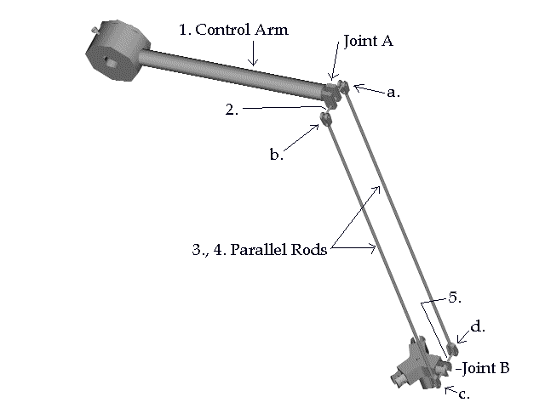
Fig. 12: Serial Arm Extension [Shane98]

- The control arm (part 1 in Fig. 3), which is rotated by the motors about the motor axis.
- The forearm, which connects the control arm to the gripper plate. It consists of two parallel rods (parts 3, 4 in Fig. 3)which are connected to form a parallelogram.
The connection between the forearm and both the control arm and the gripper plate is similar to a universal joint set-up. The forearm can rotate about the axes of part 2 and of part 5 via joints 'A' and 'B' as shown in Figure 3. In addition, the parallel rods can each rotate about the axis normal to the parallelogram via joints a, b, c and d as shown in the figure.
The connection of a forearm to the gripper plate allows for rotational adjustments in the 'α' direction to be made. This ensures that the motors can be rotated in the 'α' direction without affecting the orientation of the gripper plate. Thus the gripper plate is maintained in a horizontal plane parallel to the base plate. No adjustments in the 'β' direction have been allowed for. Thus, as each of the motors are rotated in the 'β' direction, the gripper plate is automatically rotated in the 'β' direction in its horizontal plane by the same amount. Note that the angle turned through in the 'β' direction must the same in magnitude and direction for each of the three motors with this set-up.
The parallel structure of the forearms ensures that the orientation of the gripper plate remains constant with respect to the base plate for given values of 'α' and 'β'. It also ensures that the gripper plate stays parallel to the base plate. The parallelogram structure of each of the forearms can be replaced by a single solid rod for the purpose of kinematic modelling using these constraints.
This mechanical set-up provides three degrees of freedom for the gripper plate controlled by the three actuated motor angles.

Kinematic Model
The reason for offsetting the pivots for the 'β' rotation of the motors by 'Rb' is that it maintains the kinematic similarity between the DELTA and NUWAR robots. For the DELTA model (α, β = 0), one can set up the motor axes by initially offsetting them by 'Rb', so that the arms all meet at one point (the centre of the gripper plate). With the current mechanical set-up for the NUWAR robot, the motor axes can be placed at the same point as for the DELTA robot (offset by 'Rb') and can then be rotated in the 'α' and 'β' directions at this point. The reason for this is shown below:

Fig. 13: Kinematic Model for the NWUAR Robot

As a motor is rotated by β1 as shown above, the gripper plate is rotated in the same way by β1. Thus, in order to offset the motor axes so that the arms will meet at the centre of the gripper plate, one must subtract the gripper vector Rb from the motor position with respect to the base coordinates (x₀, y₀, z₀). Because the pivot point for the 'β' direction has already been offset by 'Rb', this subtraction process is carried out automatically. The reason for doing this was because the calculations made during 1997 (regarding the workspace for the NUWAR robot at differing settings of 'α' and 'β') were made on the assumption that the motor axes were at the positions shown (offset by 'Rb'). These workspace calculations are documented in [Miller97]. Therefore to realise the improvements in workspace predicted, the same kinematic set-up must be achieved.

Coordinate Frames
The coordinate frames have been defined as follows:

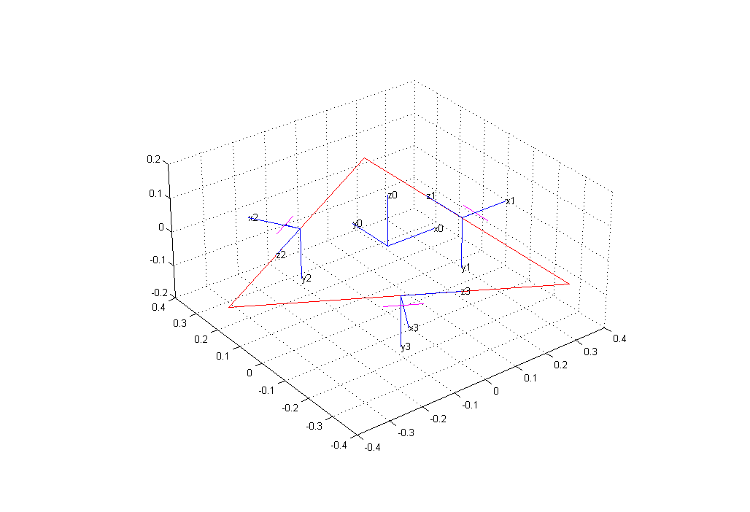

Fig. 14: Base and Motor Coordinate Systems (α, β = 0)

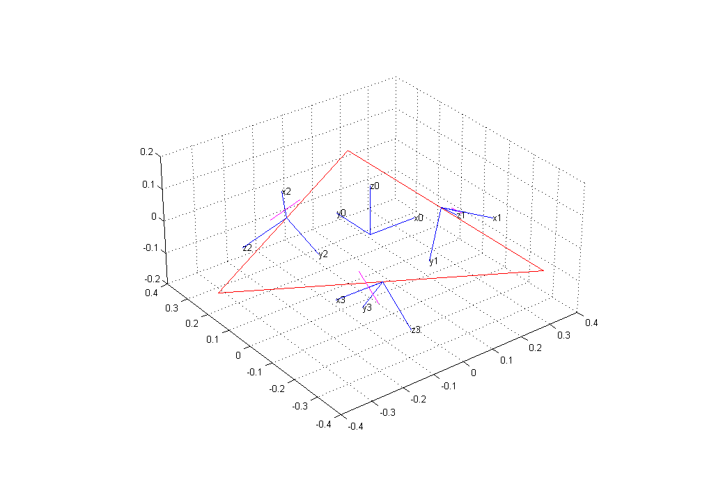

Fig. 15: Base and Motor Coordinate Systems (α = -35.26°, β = 60°)

Each motor axis can be represented by a homogeneous matrix as described earlier. This was done in MATALB by using the 'DHtrans' function which creates a Denavit-Hartenburg matrix. This was used to set up the motor frames for 'α' and 'β'equal to zero. Two rotations were then performed to rotate the motors by α and β. The motor matrices were initialised in the positions shown in figure 6 with matrices as shown below:
[motor]₁ = [Rotz(0) Trans(0,0,0) Trans(Ra-Rb,0,0) Rotx(-90°)]_{DH} Roty(β)Rotx(α)
[motor]₂ = Rotz(120°)[motor]₁
[motor]₃ = Rotz(240°)[motor]₁
Because the motors always lie in a circle, the matrix representing frame 1 can be rotated through 120° about the base frame z-axis to get frame 2 and so on. This is an efficient computational process.

Any point in motor frame coordinates can be found in base coordinates via:
P₀ = [motor]_{i} P_{i}, where P_{i} is coordinates of the point 'P' in the i^{th} motor frame, P₀ represents the coordinates with respect to the base frame and [motor]_{i} is the matrix representing the i^{th} motor frame. This process can be reversed by inverting the ith motor matrix [motor]_{i} via the process described earlier. The MATLAB function "invht" performs this operation.

